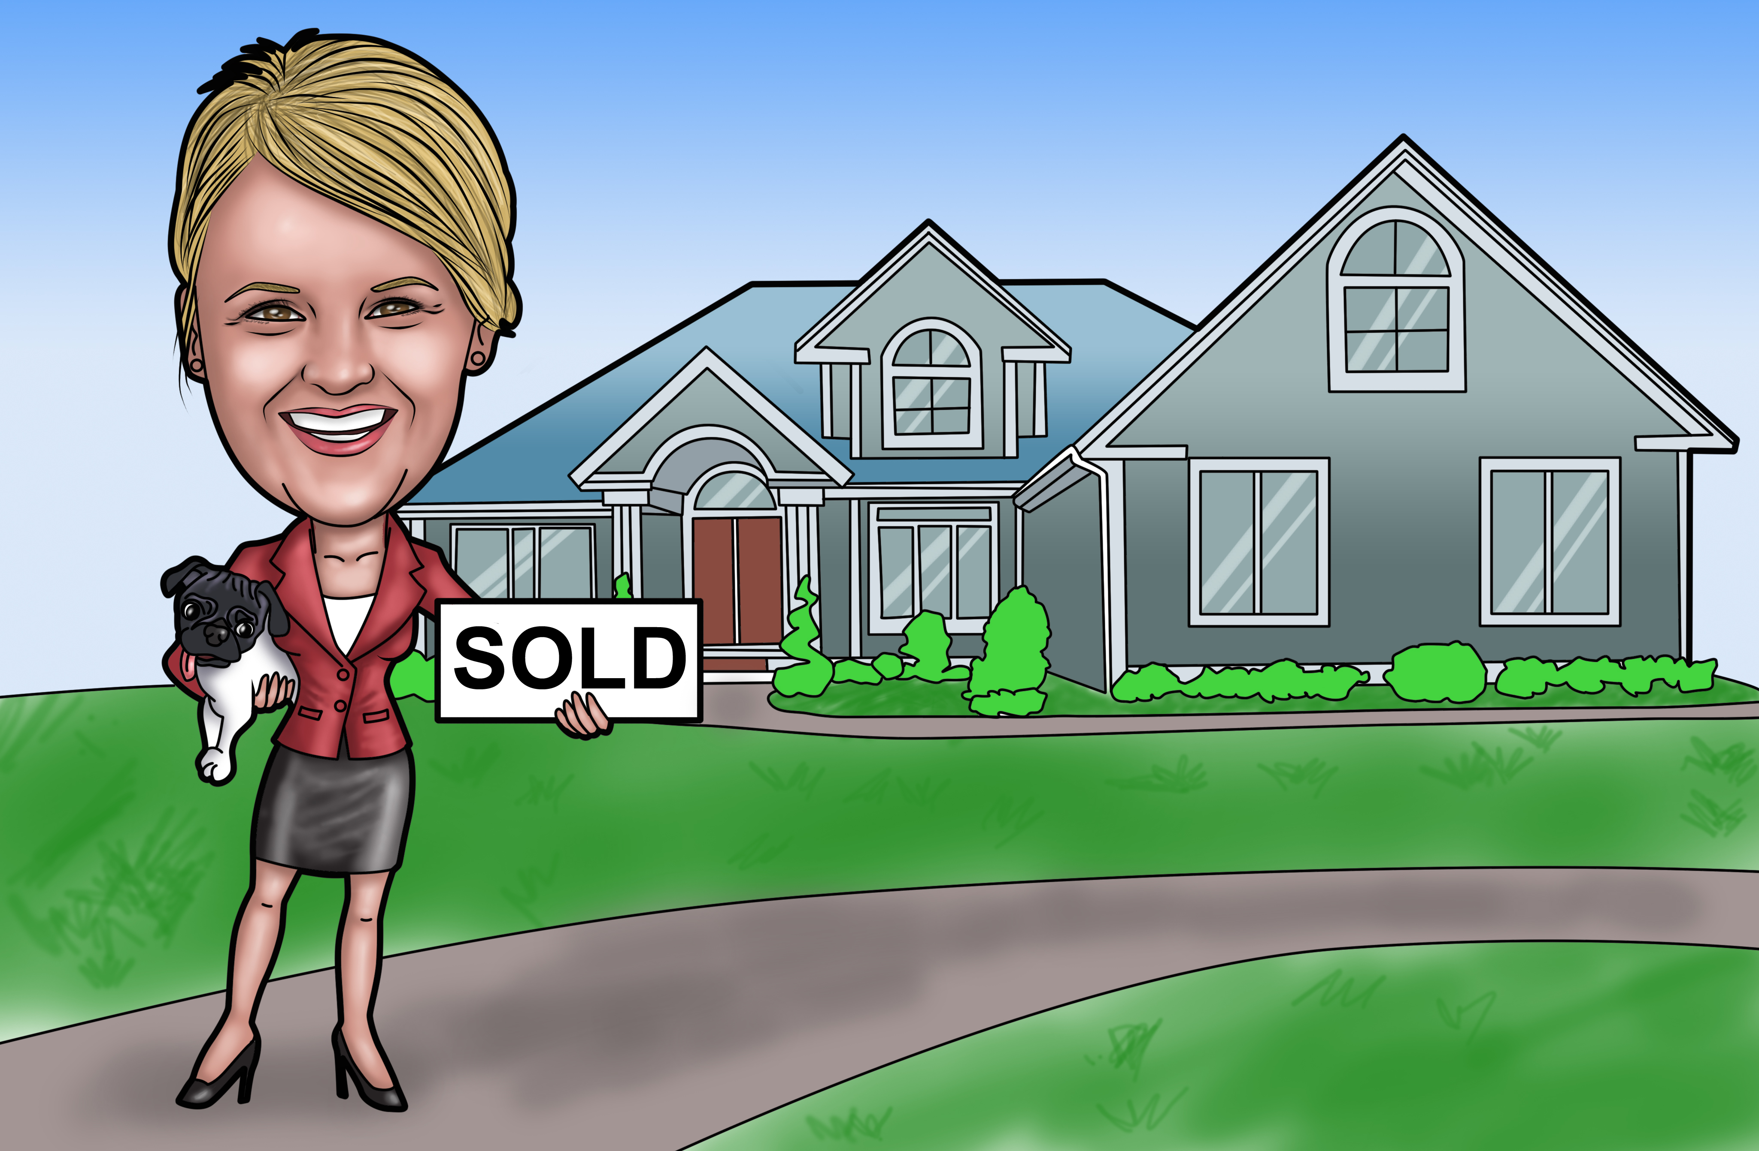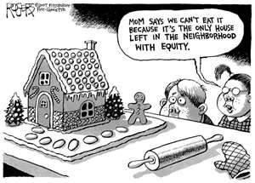

According to the Nation Assoc. of Realtors home prices continue on an upward trend, sales on existing homes are up 11% from last year at this time and homes are selling faster (shorter days on the market). This is great news for sellers! To read more about this please visit my website. To get a free snapshot of your home’s value, please call or email me.

National Real Estate News

My name is Jennifer Duffy and I am a Realtor at Southern Charm Realty of Central Florida LLC in Ocala. Like you, I enjoy living, shopping and participating in the activities and events in our community. I have assembled a monthly newsletter to give you the “lowdown” on market trends in South East Ocala and other information that may be relevant to our community. I hope you find it helpful. If you have any comments or ideas and/or stories you would like to share, please contact me at [jen@ocalaneighborhoods.com](mailto:jen@ocalaneighborhoods.com).

**Please be sure to visit my website for a monthly** **newsletter with more valuable information on local events, market news and the best LOCAL property search in Ocala.** [**www.ocalaneighborhoods.com**](http://www.ocalaneighborhoods.com)

|  |  |  |  |  |
| --- | --- | --- | --- | --- |
|  | SE Ocala October 2011 | SE Ocala  October 2012 | Marion County  Oct 2011 | Marion County October 2012 |
| New Listings | 80 | 88 | 759 | 671 |
| Closed  Sales | 35 | 35 | 301 | 370 |
| Days on Market | 176 | 194 | 204 | 204 |

#### South East Housing Statistics

OcalaNeighborhoods

OcalaNeighborhoods

### Hello Neighbor!!

Real Estate News and Community Views

SOUTH OCALA LOWDOWN

FALL 2012

**Jennifer Duffy (352) 509-1767 jen@ocalaneighborhoods.com**

**Ocalaneighborhhods.com**

**Save the Date!**

Ocala Christmas Parade

December 8th 2012

5:30 pm

Silver Springs Blvd

**Save the Date!**

Ocala Christmas Parade

December 8th 2012

5:30 pm

Silver Springs Blvd

Easy Peanut Butter Cookies

1c. Peanut butter

1c. Sugar

1 egg

1 tsp Vanilla

Preheat oven to 350. Mix all ingredients and bake. Scooping mounds of dough using a medium cookie scoop will yield perfect shaped cookies every single time.  Using the tines of a fork to press the dough down gives each cookie that recognizable, signature peanut butter cookie look. Bake the cookies for 10-12 minutes until they are golden around the edges. Allow the cookies to rest on the counter for 2 minutes before transferring them to a cooling rack.

Gluten Free as well!!

Staging tips to get your SE Ocala Home SOLD!

If you are thinking of selling your home, staging is well worth the investment of time and money. It has be proven that well staged homes sell faster and for more money, so roll up your sleeves and get ready to work. Here are a few quick tips to get you started.

1. Clutter Free- Remove excess clutter! Clean, open space will sell your home. Nondescript décor allows people to envision living in your home. Consider putting excess possessions in storage and keeping out only what is absolutely necessary.  Remember:  You’re going to be packing up to move ANYWAY so, why not start the process now and be ahead of the game?

2.  Clean living – It goes without saying; scrub every inch of your home.  Nothing kills a sale faster than bugs scurrying across the floor or a filthy kitchen sink.

3.  Neutral paint colors – When you move into your new home, feel free to paint every room pink and purple if you’d like, but for staging purposes, stick with muted, light colors

4.  [Don’t forget the yard](http://www.icharlotterealestate.com/clean-up-for-your-charlotte-home-for-sale/) – Curb Appeal! Keep lawn maintained and plant a few flowers. Get rid of any junk like old swing sets or unused cars.

If you’re looking for more information about listing your SE Ocala home for sale or need more staging advise, I can help.  Give me a call today at(**352) 509-1767 or email me at Jen@ocalaneighborhoods.com**

Recipe of the Month